**A Quasi-Experimental Study into Parents' and Teachers' Beliefs on the Impact of Imaginary Companion Play and Pretend Play on Children's Development and School Readiness.**

Student ID: 19887636

Department of Psychology, University of Kent

Research topic: Imagination in children

Word Count:

**Introduction**

Play is key part of children’s early development and was declared a right for every child by the United Nations High Commissioner for Human Rights (OHCHR, 2006). Play has been shown to help with the development of social, cognitive and language skills, which are all vital for school readiness (Dickinson & Tabors, 2001; Owen, 2021; Prins et al, 2022). Naturally, an ever-growing body of research is focusing on the beliefs and attitudes of adults towards play in children’s development (Parke & Ladd, 2017). It is vital that carers of children have a strong understanding of not only why play is so important but, additionally, how to encourage it.

In recent years there has been a significant shift in the importance of pretend play in children development over the idea of it being only for the purposes of fun (Fogle & Mendez, 2006). This has been shown to be especially apparent in the Western World (Waters et al., 2022). A significant part of the research, however, has demonstrated this shift has occurred in other cultures (Y. C. Lin & Yawkey, 2013). For example, in China pretend play has historically been considered frivolous as it distracts from academia which is often thought of as most important for children’s development. Lin and Li (2018) researched Chinese parents play beliefs and found an increased support for parents as teachers during play with their children.

**Hypothesises**

**The first hypotheses were that both parents and teachers will view pretend play as more important for emotional, social, and communicational skills when compared with IC play**. This is because IC play is generally viewed more negatively for children’s development against pretend play (***Insert reference here)***. Attitudes, however, in the western world towards IC play have begun to change in recent years. Research suggest that attitudes have changed towards the importance of IC on children’s development. (***insert reference here*)**.

**It is likely that teachers will view pretend play to be even more significant in children’s development when compared with parent.** This is because teachers see the difference between children who play a lot and those who don’t. Therefore, they can assess the benefits of pretend play when comparing children. ***(insert reference here)***.

**Additionally, there will be no difference in parents and teachers’ beliefs on the importance of imaginary companion play for school readiness**. Based on previous research both parents and teachers are likely to see IC play as fun for children ***(insert reference here)***.

Teachers may see and hear about IC play less at school as children are more likely to play and interact with their peers during school hours compared to at home ***(insert reference here)*. For this reason, it was expected that teachers over parents are likely to view pretend play as more important for school readiness.**

**Methods**

**Participants**

120 eligible participants were recruited from the general population via a volunteer sampling method. Eligible participants consisted of those who are either a parent with a child aged 11 or below or a teacher of children in Year 6 or below. Recruitment occurred via Qualtrics, social media advertising and reaching out to mutual contacts of the researchers through personal means (e.g., texts and calls). This recruitment strategy was most appropriate as the study was a questionnaire completed online at the participants convenience. Participants were offered the opportunity to provide their email at the end of the study if they wanted the opportunity to enter a draw to win 1 of 6 £40 gift cards.

**Design**

The study was set up as a quasi-experimental 2 x 2 mixed-subjects design. This was a self-reported questionnaire. Parents were assigned to the parental section of the questionnaire and teachers were assigned to the teacher section of the questionnaire. Both sections of the questionnaire asked the same IC play and pretend play questions, however, contained different additional question to gain more appropriate information about a child’s home environment vs the classroom environment (see Appendix A & B). Participants received the questions in a randomised order to reduce the chances of order effects.

**Procedure**

Prior to the studies distribution the researchers developed a parental and teacher beliefs questionnaire which was adapted from The Parent Play Beliefs Scale (PPBS) (Fogle & Mendez, 2006). The questions were specified to IC play and pretend play, 2 additional questions were added, and repetitive questions were removed. The PPBS scale (Fogle & Mendez, 2006) was designed to discover beliefs about the significance and practicality of children’s play when compared with traditional academic learning. The researchers chose to use the PPBS as it was the first parent belief questionnaire to use a rating scale was sufficient psychometric properties. The factors uncovered by Fogel & Mendez for the PPBS, Play Support and Academic Focus demonstrated satisfactory reliability, with Cronbach’s alphas of .90 and .73, respectively.

The questionnaire was then developed on the software platform Qualtrics® for the participants to complete. All participants first read the informed consent, confidentiality and withdrawal from the study page and consented to taking part in the study. Participants were informed the aim of the study was to investigate adults’ beliefs about children’s engagement in different types of play. All participants then created an anonymous 5-letter participant code so their data could be identified in the event they wish to withdraw their information from the study. All participant provided demographics about their gender, age, and ethnicity.

All participants then answered questions about their beliefs for Imaginary Companion (IC) play and pretend play. Participants were provided with a definition of each type of play. They then answered their beliefs about to what extent are IC and pretend play are important for the development of thinking abilities; social, emotional, and communicational skills; preparing to start school; if the type of play is fun for children; and if it is more important that other types of play (see Appendix A). Additionally, all participants answered questions about digital play, physical play, sensory play, exploratory play, structured play, free play, and general play beliefs. These are not relevant to this paper and will not be discussed further. Participants answered using a Likert-type scale. Participants were then given the opportunity to provide their email address if they wanted the opportunity to win a £40 gift voucher. Finally, the participants were debriefed as to the purpose of the study.

***Parental Section of Questionnaire***

Participants were asked to consider one child, if they had multiple, when completing the questionnaire. The researchers collected demographic information on the child age, gender, and any diagnosis’s (including ADHD, Autism Spectrum Disorders, Learning Disabilities, Physical Disabilities including visual or hearing impairments or mental disorders). Additionally, participants were asked more general questions about their child’s interests and how many hours a day their child spends on different types of play (see Appendix B).

***Teacher Section of the Questionnaire***

In the teacher section the researchers collected demographic information on the class the participant teaches, how many children are in the class, the gender divide and if there are any physical or mental learning disabilities. Moreover, information on how much time the children spend playing outside and the use of digital devices in the classroom was collected (see Appendix B).

**Measures**

The dependent variable (DV) was the participants beliefs about the play types on development. Participants answered on a 5-point Likert-type scale (*1 – strongly disagree, 2 = slightly disagree, 3 = neutral, 4 = slightly agree, 5 = strongly agree*) for the IC play and pretend play questions (see Appendix A).

**Analysis Plan**

This research collected data unrelated to this study. Therefore, unnecessary data surrounding other play types was deleted. The data was then transformed into numerical values (e.g., Strongly Disagree = 1, Disagree = 2, Neutral = 3, Agree = 4, Strongly Agree = 5). Responses where then averaged for developmental skills questions (e.g., communication, social and emotion) and school readiness questions for IC play and Pretend Play. This obtained a Likert-scale score for IC play and pretend play respectively. To test each hypothesis four one-way ANOVAs were run. The independent variable (IV) is whether the participant receives the parent questionnaire or the teacher questionnaire. The dependent variable is their beliefs about the play types on development.

**Ethical Considerations**

We anticipated none to very little discomfort to participants upon completion of the survey. Nevertheless, participants were provided with an information sheet briefly explaining the purpose of the study and signed a consent form. This ensured participants were completing the questionnaire freely and voluntarily and were aware they had the right to withdraw at any time. Furthermore, participants confirmed they had read the information sheet and were aware their data would be treated confidentially. Participants were asked to make an anonymous 5-letter code which can be used to identify them in the event they wish to withdraw their data. A debrief was provided at the end of the questionnaire explaining the purpose of the study. All researchers’ full names and email addresses, including the supervisor, were provided in the event of a participant wishing to contact the team.

**Appendix A**  
  
  
  
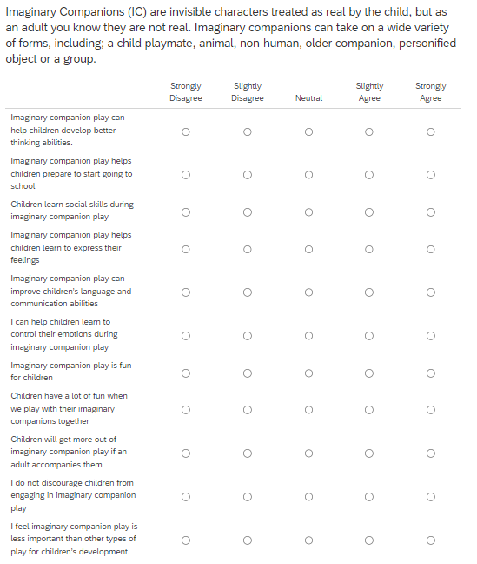

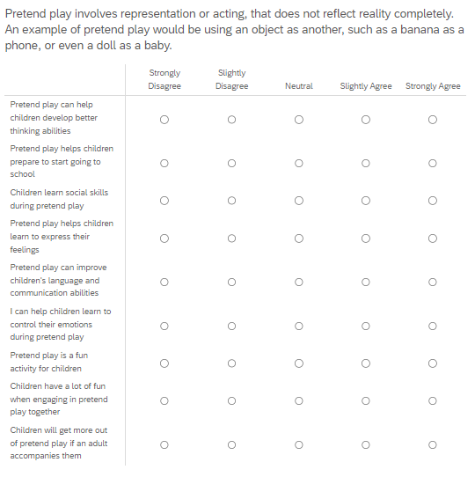

**Appendix B**

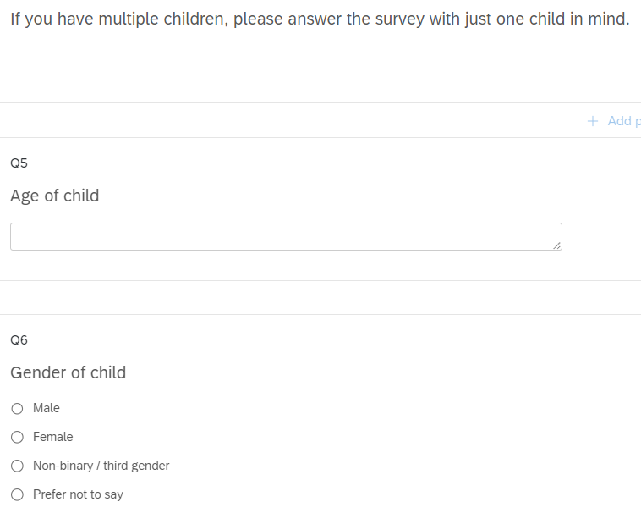

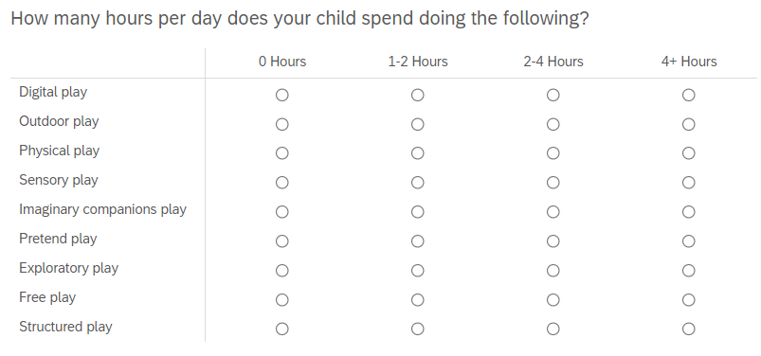  
  
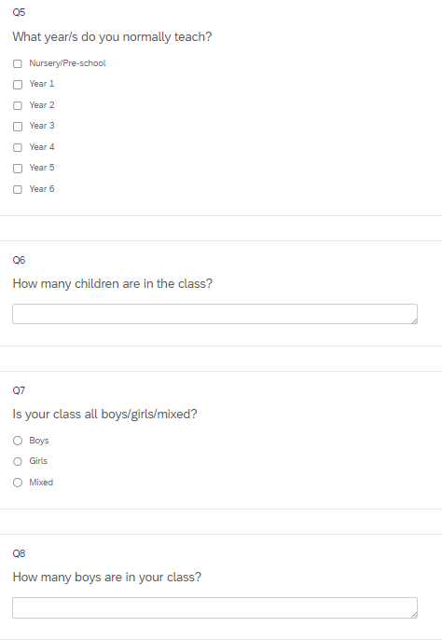

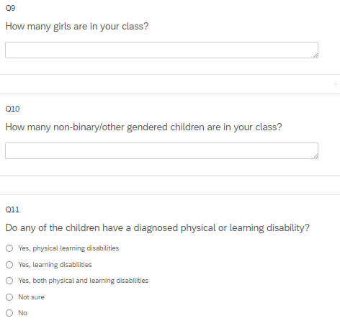

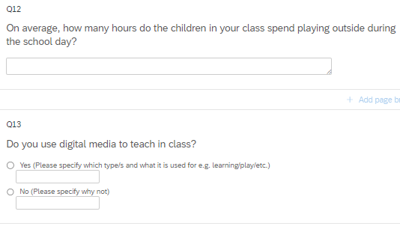

**References**

Office of the High Commissioner for Human Rights (OHCHR). 2006. General Comment No. 7 (2005): 01/11/2006. Implementing child rights in early childhood. http://www2.ohchr.org/ english/bodies/crc/docs/AdvanceVersions/GeneralComment7Rev1.pdf. Parmar, P., S. Harkness, and C. M. Super. 2004. “Asian and Euro-American P